**Bike Sharing**

**Do Weather Patterns Affect the amount of Bike Rentals there are? What Weather Type has the highest/lowest amount of bike rentals? ​**

* Yes, different weather patterns all have different effects on bike rental usage. When it is clear and sunny there is an increase in bike rentals. When it is raining there is a huge decline in usage.

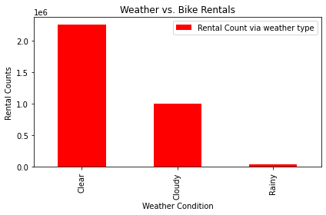

**Does a particular season have higher or lower rentals? Why?​**

* Yes, Fall has the highest usage when it comes to rentals. This is because there are more clear and sunny days while Spring has the lowest. Spring has the lowest due to more rainy days.

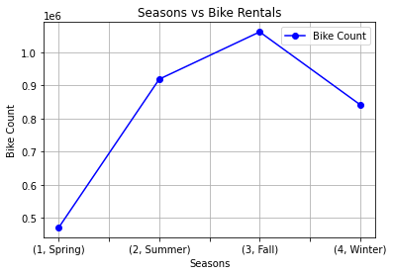

**Are there any trends in rental amounts when it is a weekend vs a weekday? How about rental usage during holidays?​**

No. There is no correlation when it comes to the day of the week and it seems as if weather and environmental factors are the main factor.

